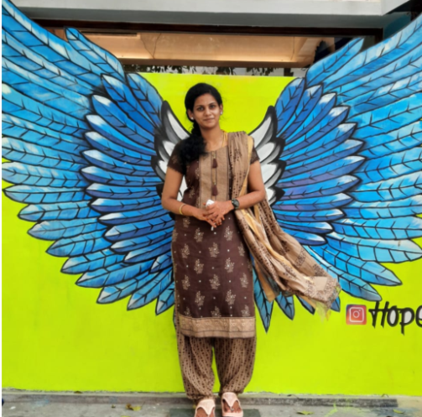

**Front End Developer**

Sangeetha Chandrasekar

Books

Problem Solving

**CAREER OBJECTIVE**

Painting1997 - 2012

To be able to work for an encouraging company that will assist me in developing, improving, and obtaining the necessary skills in order to become the best engineer possible.

**TECHNICALPROFICIENCIES:**

**EDUCATION**

**BACHELOR DEGREE**

Bachelor of Computer Science and Engineering

2012 2016

JavaScript, JQuery, HTML, HTML5, CSS, CSS3, Web Programming Skills, E-Commerce, Teamwork, Verbal Communication,

cross-browser compatibility, Web User Interface Design (UI) , API's

**CONTACT**

KCG COLLEGE OF TECHNOLOGY

May 1997 – May 2012

portfolio_icon.png

**HOBBIES**

Date of Birth: Dec 30, 1994Age: 26Gender: FemaleBirth Place: Chennai

**ABOUT ME**

Problem Solving

Painting

Books

**INTERESTS**

https://[sangs1994](https://sangs1994.github.io/Portfolio/).github.io/Portfolio/

**CUSTOMER SUCCESS ENGINEER**

sangeetha94.chandrasekar@gmail.com

+91 9791081218

O : 30 N : 20/2, Sollaiamman Koil Street, Pursaiwakkam

GIT

MySQL

JIRA & Trello

NodeJS

CSS3 ,SASS ,Bootstrap

HTML5

Javascript

AngularJS & Angular 10

JQuery

**SKILLS**

* Helped build and enhance highly available, scalable, real-time and secure mobile application used by various customers.
* Completed five major projects, working closely with agile development team to develop, test and maintain mobile -based applications.
* Adhered to high-quality development standards while delivering solutions on-time.

Collaborated in a team-focused environment providing software solutions to diverse industry clients and key contributor to startup company.

2016 to 2019 | APPSFREEDOM PVT LTD– CHENNAI, TN

* Collaborating with UX designer and Backend team to implement many features across the WCM product.
* Migrating the Angular JS application to angular 10 by hybrid approach.
* Integrating the Unit test cases for around 60 % of the existing application using Karma/Jasmine and code coverage for AngularJS application using Karma Coverage.

Key contributor to WCM team in handling development and customer related issues in parallel.

2019 to present | SCIENTIFIC GAMES–CHENNAI , TN

**SOFTWARE ENGINEER**

1997 2012

**EXPERIENCE**

Rosary Matriculation Higher Secondary School

**SCHOOL**

Internship:Automatic Ticket Monitoring System (Web) Jan 2016 – Jun 2016 | AIRCEL Business Solution